**FPT ACADEMY INTERNATIONAL**



## FPT – APTECH COMPUTER EDUCATION

HKN GROUP

|  |  |  |  |
| --- | --- | --- | --- |
| **Center Name** | | FPT – Aptech – HCM2  Address: 590 Cach Mang Thang Tam, District 3, Ho Chi Minh City | |
| **Instructor** |  | Ms. Le Mong Thuy |  |
| **Class** |  | T1.2104.E0 |  |
| **Group** |  | 1 |  |
| **Group members** | | **Name** | **Student ID** |
|  |  | Phạm Quốc Khánh | Student1316207 |
|  |  | Trương Thành Nghĩa | Student1316198 |
|  |  | Nguyễn Văn Hùng | Student1309635 |
| **Duration** | Start date | 13 - Jan - 2022 |  |
| End date | 27 - Feb - 2021 |  |

**This is to certify that**

**Mr.:**

Phạm Quốc Khánh

Trương Thành Nghĩa

Nguyễn Văn Hùng

**has successfully designed & developed**

eProject: Historical Monument website

**Submitted by:**

Pham Quốc Khánh

**Date of issue:**

14-07-2021

**Authorized Signature:**

TABLE OF CONTENTS

FPT – APTECH COMPUTER EDUCATION

ACKNOWLEGMENT 3

SYNOSIS 3

PROBLEM DEFINITION 4

CUSTOMER'S REQUIREMENTS SPECIFICATIONS (CRS) 5

SCOPE OF THE WORK (IN BRIEF) 7

ARCHITECTURE AND DESIGN OF THE SYSTEM 8

DIAGRAM OF THE WEBSITE 9

TASK SHEET REVIEW 1 10

SITE MAP 11

HOME 12

GALLERY 13

MUSEUM 14

WORLD AND VIET NAM 15

FEEDBACK 16

CONTACT US 17

TASK SHEET REVIEW 2 18

WEBSITE DESCRIPTION 19

JAVASCRIPT DESCRIPTION 28

TASK SHEET REVIEW 3 34

# ACKNOWLEGMENT

On behalf of all the members of group 7, I would like to thank you all for the hard works, supports to make this eProject complete successfully. Especially, Ms. Le Mong Thuy, our teacher, she helped us a lot from the day that we started to study at FPT Aptech. With this eProject, she has guided us with her enthusiasm and rigorous, because of her guiding, we would be able to finish this project. Besides, I want to thank all the team member of group 7, each of the team member has been working continuously in 4 weeks in order to complete this project. The last but not least, we would like to say thank you to our family for always supporting us, creating the best conditions for us to focus on the project, and putting faith in the dreams we pursue.

# SYNOSIS

We need to create a website that meet all the requirement of our customer,HKN Group is a webpage about history that not only provide the places but also all of the travel. We have a big collection about museum on the world and inside Viet Nam. The main purpose of this website is to reach to the customer, who have interest in travel and looking for history that they can live with their passion. Come to HKN Group, customer can also be a member that has a lot of discount and special offer.

# PROBLEM DEFINITION

The Web site is to be created based on the following requirements.

1. The Home Page should be created making use of Sections with a suitable logo, the header section can be added which will show different famous images of monuments.
2. The site must contain the links to navigate through any zone for the information.
3. Links of monuments can be categorized by zone wise like (East, North, West and South) apart from world wonders link can be added.
4. History behind all the monuments can be added along with the images.
5. Gallery section can be added for viewing different images.
6. Feedback must be allowed to enter by the viewer
7. Site map, Gallery, about us, Queries link, Contact us link must be added.
8. The “Contact Us” page should have the Address of the Company and the mail address which when clicked will invoke the local mail client from where they can send an email. Address of the Company should be displayed using GeoLocation API (eg. GoogleMaps).
9. The complete historic reason and its description must be allowed to get download as pdf or doc file.
10. The advertise section of bus, flights can be included for reaching the places.

# CUSTOMER'S REQUIREMENTS SPECIFICATIONS (CRS)

**Client: HKN Group.**

History/ Project Objective: Historical Monument

HKN Group, specializing in the field of historical discovery. We not only provide historical sites and museums around the world for everyone to explore, but also are ready to organize learning trips for everyone.

The website is to be developed for the Windows Platform using HTML5, JavaScript, Bootstrap, jQuery and Geolocation. The site should work well in all leading browsers including Chrome, IE, Firefox etc.

**Input to the system:**

* + - * Search for historical sites, museums, and trophy displays.
      * Assistance with proper transportation by airplane and bus on site.
      * It is allowed to download all of the information about your place you interest in.

**Output from the system:**

* + - * A menu will categorize all the website functions.
      * Detailed information about the museum (year of establishment, related to the storage of artifacts ...)
      * Clip or image will be public in gallery.
      * Classification of domestic and foreign regions.
      * Sort by geographical location
      * Support with flight or vehicle information.
      * Support in organizing the tour.

**Process**:

* + - * Validate data input from users.

**Expected delivery date:**

* + - * 14-July-2021

**List of deliverables:**

* + - * Document Word.
      * User Guide.
      * Source code.

Hardware/ Software Requirements:

* **For developer**

**Hardware**

* + Intel Pentium 166 or better.
  + 64 Megabytes of RAM or higher.

**Software**

* + Notepad/HTML editor
  + Dreamweaver
  + IE 5.0/ Netscape 6.0
  + Web browsers such as IE, Chrome or Firefox are supporting HTML5, CSS3 and Javascript.
* **For web users**

**Hardware**

* + Intel Pentium 4 processor or higher
  + 512 Megabytes of RAM or higher

**Software**

* + Windows XP OS or higher
  + Web browsers such as IE, Chrome or Firefox are supporting HTML5, CSS3 and Javascript.

# SCOPE OF THE WORK (IN BRIEF)

After a long and detailed discussion, our group has decided to create a website contain the following webpages:

1. ***Homepage***: Display information about HKN group, information of museum.
2. ***Galary*** : Display the picture.
3. ***Museum***: Display all available museum on the world and Viêt Nam.
4. ***Contact us***: Display the address of the company, allow customers to request any information
5. ***Feedback***: Display all comments and the score of user.
6. ***Site map***: Display the information of the company, clients’ review and about us.

# Architecture and design of the system

Webpage request



Requested Page

**RENDERING**

**ENGINE**

**CSS CODE**

**HTML CODE**

**WEB SERVER**

**WEB BROWSER**

**CLIENT**

**SERVER**

# Diagram of the website

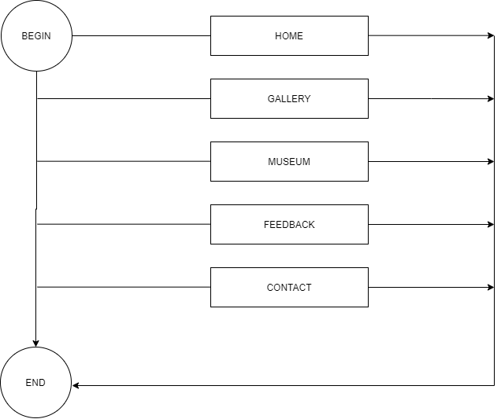



# TASK SHEET REVIEW 1

|  |  |  |  |  |  |  |  |
| --- | --- | --- | --- | --- | --- | --- | --- |
| **Project Ref. No.:**  **eP/Advertisement Portal Management**  **System/01** | | **Project Title:** | **Activity Plan Prepared By:** | **Date of Preparation of Activity Plan:** | | | |
| **Sr.**  **No.** | **Task** | **Actual**  **Start Date** | **Actual Days** | **Team**  **Mate Names** | **Status** |
| 1 | Problem Statement |  | Khánh | 15-July-21 | 1 | Khánh | Completed |
| 2 | Analysis of HKN Tourist requirements about the website | 15-July-21 | 1 | Khánh | Completed |
| 3 | The scope of the work (in brief) | 15-July-21 | 1 | Nghĩa | Completed |
| 4 | Architecture and design of the system | 15-July-21 | 1 | Nghĩa | Completed |
| 5 | Diagram of the website | 15-July-21 | 1 | Hùng | Completed |
| 6 | Task Sheet | 15-July-21 | 1 | Hùng | Completed |

|  |  |
| --- | --- |
| **Date:** | |
| Signature of Instructor:  **Ms. Le Mong Thuy** | Signature of Team Leader:    **Pham Quoc Khanh** |

# SITE MAP

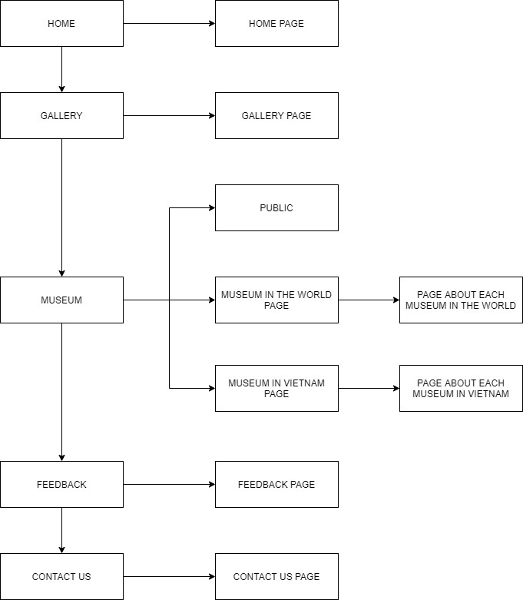

|  |
| --- |
|  |

# HOME

**HEADER**

**(NAVIGATION BAR )**

**SLIDER**

**CONTENT OF WEBPAGE**

**MUSEUMS ON THE WORLD**

**FOOTER**

**MUSEUMS IN VIET NAM**

# GALLERY

**FOOTER**

**IMAGE**

**HEADER**

**(NAVIGATION BAR)**

# MUSEUM

**FOOTER**

**IMAGE**

**HEADER**

**(NAVIGATION BAR)**

**CATELOGIES**

# WORLD AND VIET NAM

**FOOTER**

**IMFORMATION**

**SLIDER**

**HEADER**

**(NAVIGATION BAR)**

**IMAGE**

**IMAGE**

**IMAGE**

**IMAGE**

**IMFORMATION**

**IMAGE**

**IMAGE**

**IMAGE**

**IMAGE**

# FEEDBACK

**SLIDER**

**HEADER**

**(NAVIGATION BAR)**

**FOOTER**

**RATING POINT**

**FEEDBACK**

# CONTACT US

**SLIDER**

**HEADER**

**(NAVIGATION BAR)**

**FOOTER**

**TEAM MEMBER**

**MAP LOCATION**

**CONTACT FORM**

# TASK SHEET REVIEW 2

|  |  |  |  |  |  |  |  |
| --- | --- | --- | --- | --- | --- | --- | --- |
| **Project Ref. No.:**  **eP/Advertisement**  **Portal Management System/01** | | **Project Title:** | **Activity Plan Prepared By:** | **Date of Preparation of Activity Plan:** | | | |
| **Sr.**  **No.** | **Task** | **Actual Start Date** | **Actual Days** | **Team Mate Names** | **Status** |
| 1 | Site map | HKN GROUP | Khánh | 18-July-21 | 1 | Nghĩa | Completed |
| 2 | Mock of the website | 18-July-21 | 2 | Khánh | Completed |
| 3 | Task sheet | 18-July-21 | 2 | Hùng | Completed |

|  |  |
| --- | --- |
| **Date:** | |
| Signature of Instructor:  **Ms. Le Mong Thuy** | Signature of Team Leader:  **Pham Quoc Khanh** |

WEBSITE DESCRIPTION

1. HOME PAGE.
   1. **Description**
      * + This website displays the following information: Introducing HKN group, some outstanding museums in Vietnam and around the world. And what made the company founded.
        + Click on each item you feel interested in. It will lead you to each detail page.
   2. **Screenshot**

|  |
| --- |
|  |

* **Navigation bar**

1. **Description**
   * + - This menu bar allows users to navigate to every webpage of the whole website. For example, users need to click on Galerry to show the Galerry page will open. The same method is applied for other pages.
       - And in the Museum button, we have 3 link to show you the detail of another museum we have..
   1. **Screenshot**

|  |
| --- |
|  |

1. GALLERY
2. **Description**
   * + - This webpage displays all images of the website
       - Gallery page display images of antiquities in the museum.
       - Modal display images in a larger format.
3. **Screenshot.**

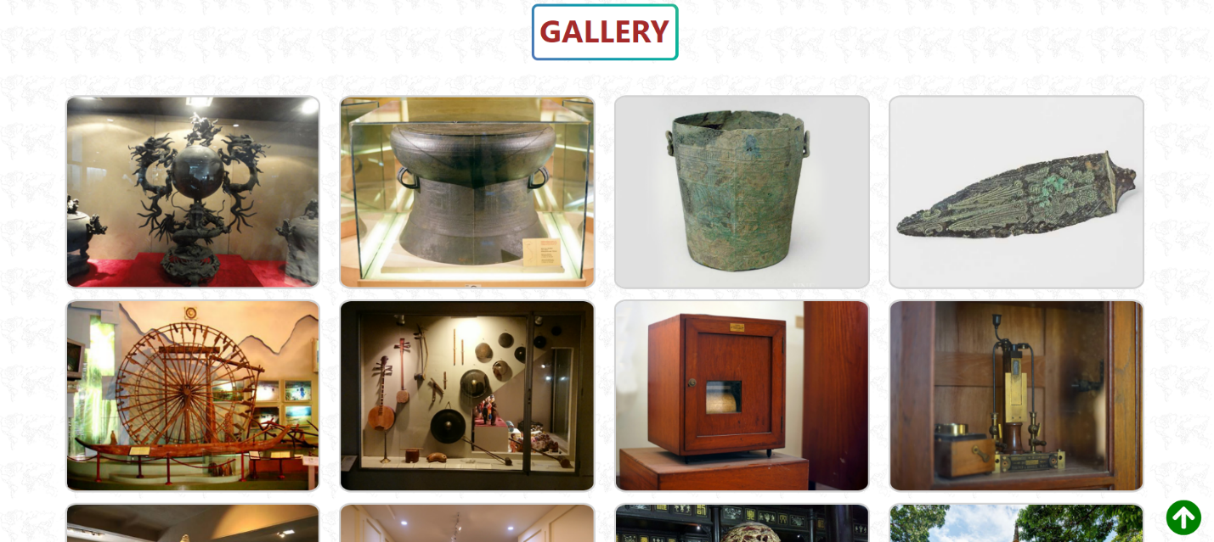

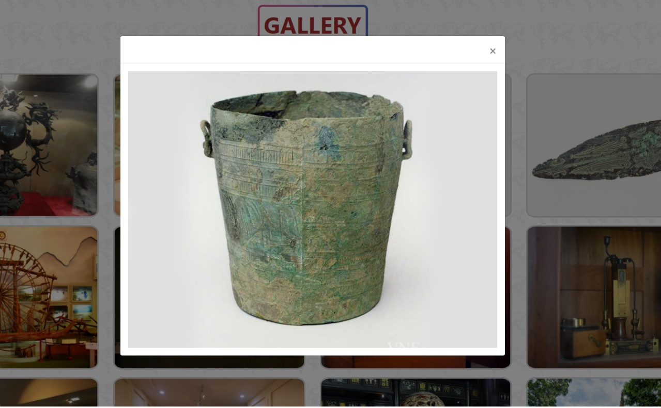

1. MUSEUM PAGE

A. THE PUBLIC PAGE

1. Description
   * + - Museum page display following information:

+ Pictures of museums.

+ Categories to categorize museums: In the world and in VietNam

+ Modal display each museum information and download it.

**2. Screenshot**

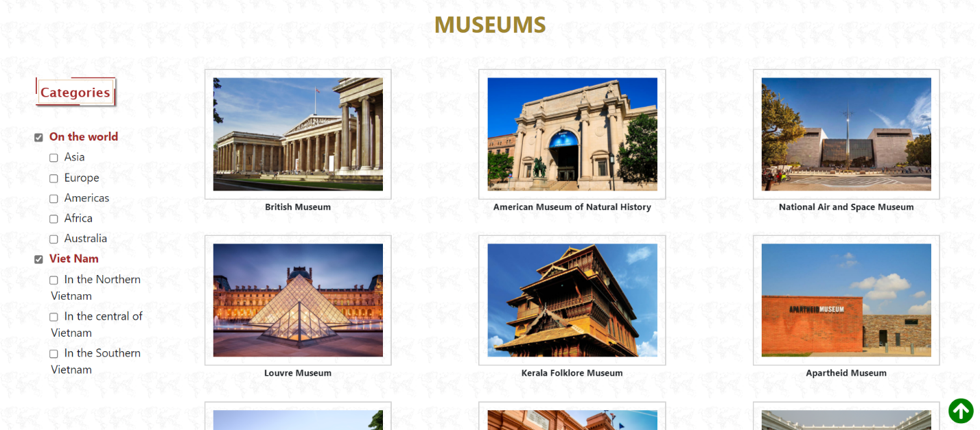

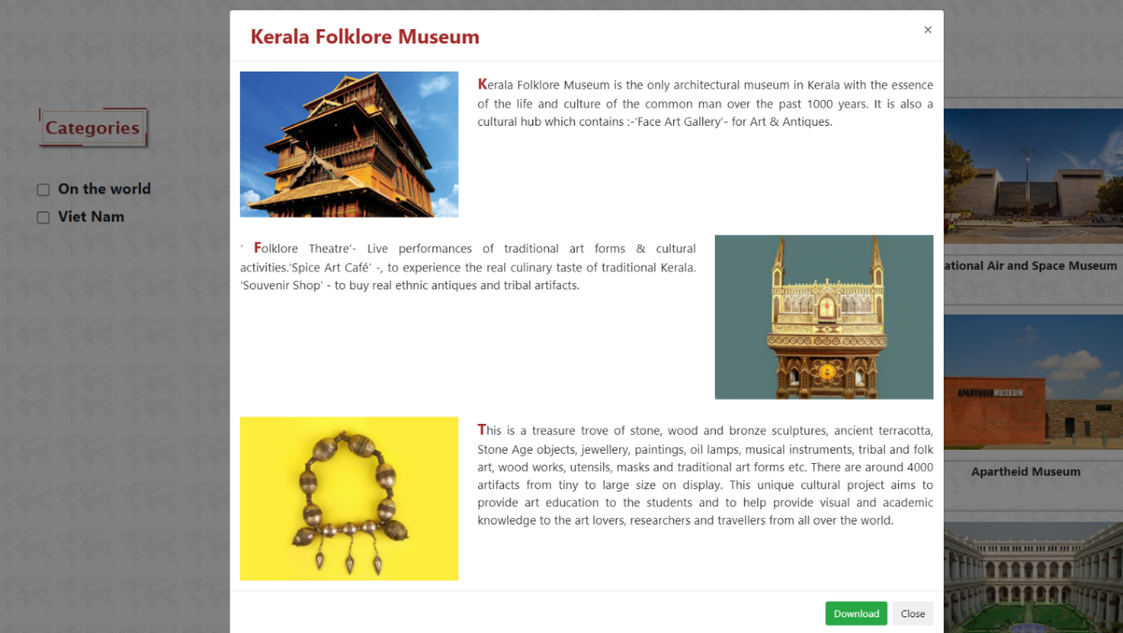

B. IN VIET NAM PAGE AND ON THE WORLD PAGE.

1. Description

This page display following information:

+ Slider pictures of museums : image, location and name.

+ Link to another web pages.

1. **Screenshot**

|  |
| --- |
|  |
|  |

* + **Example of a detailed museum page.**

1. Description

This webpage displays detailed information of museum such as: Location, history , images and link to another pages.

1. **Screenshot**

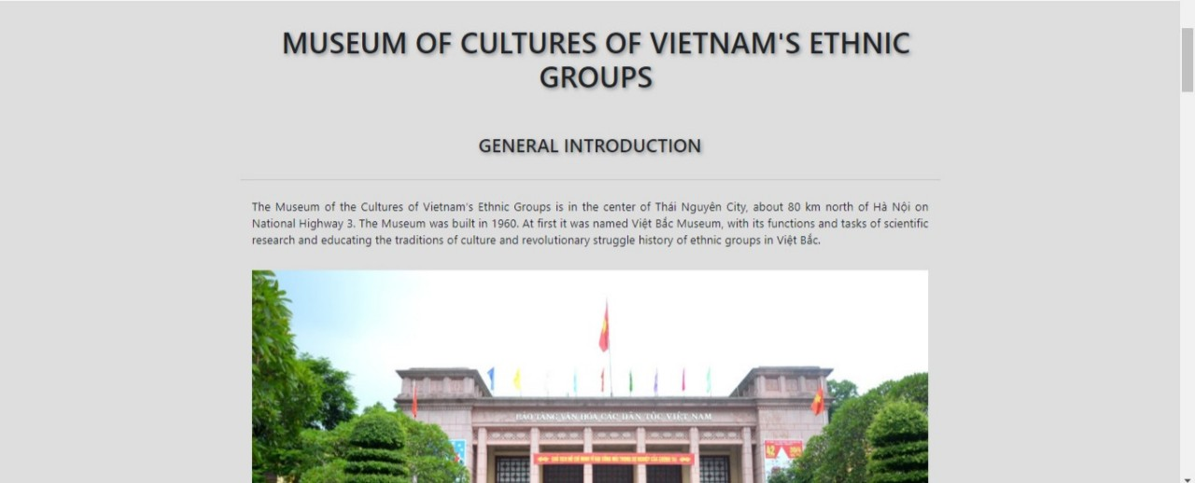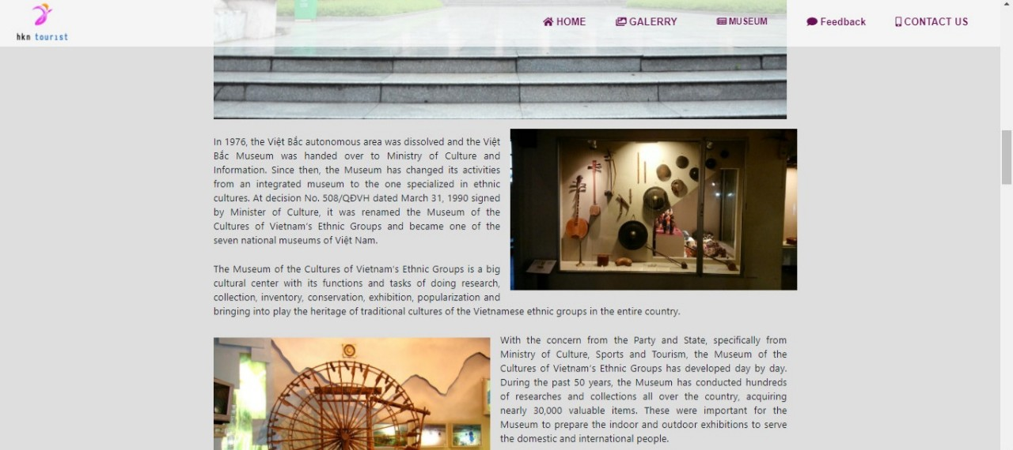

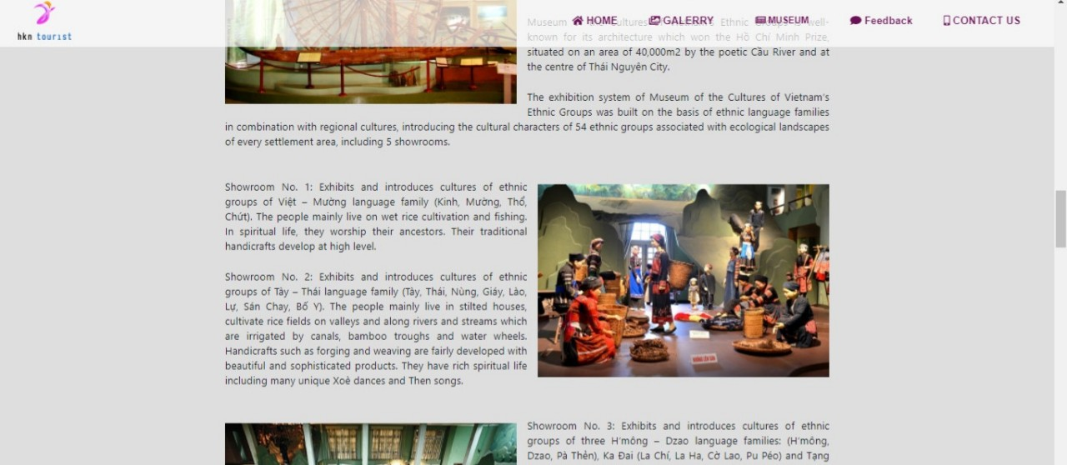

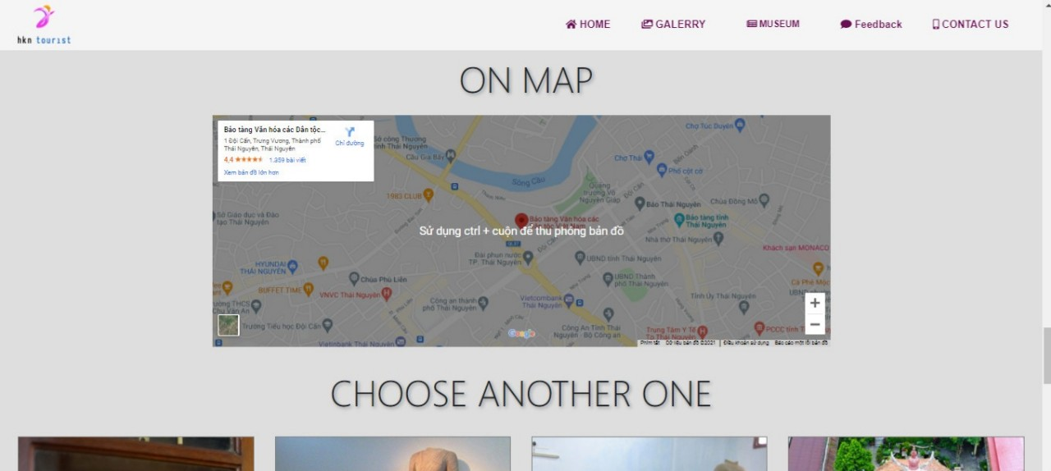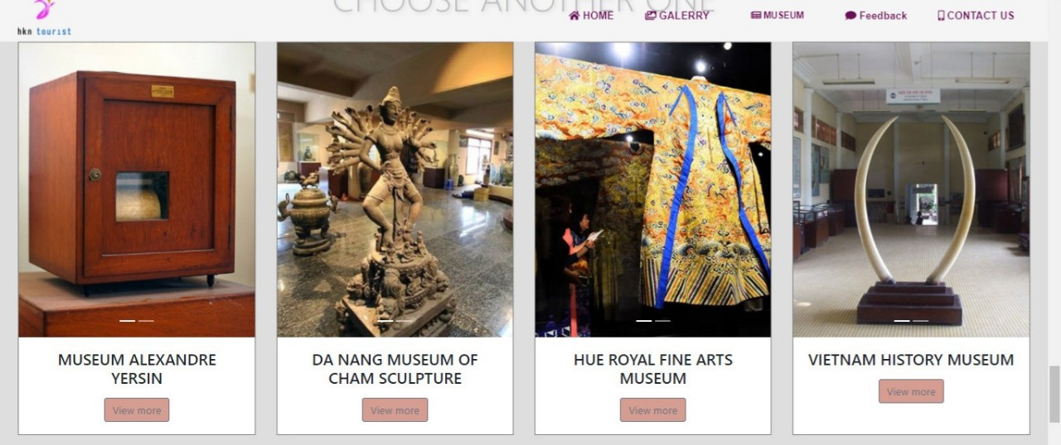



1. Feedback pages
2. **Description**

This webpage displays:

+ Good and bad feedback of user.

+ Short feedback by rating list and whole comments of the peoples. It also gives the number of stars and comments by customers who had good reviews to the pages.

1. **Screenshot**

|  |
| --- |
|  |

1. Contact Us
2. **Description**
   * + - The members who public and control this page.
       - This webpage allows users to request information they inquire to HKN group and displays the geolocation of the company.
       - Link the mail address if customer need direct help.
3. **Screenshot**

|  |
| --- |
|  |
|  |
|  |

|  |
| --- |
|  |

JAVASCRIPT DESCRIPTION

**Filter**

**Description:**

Filter museums by region (in the world and Viet Nam).

In the world filter by continent.

Viet Nam filter by region.

**Code:**

$(document).ready(function () {

            var data = [];

            var data1 = [];

            var data2 = [];

            var temp1 = [];

            var temp2 = [];

            var dat1 = [];

            var dat2 = [];

            $.getJSON("./JSON/data.json", function (items) {

                data1 = items;

                $.getJSON("./JSON/data1.json", function (items1) {

                data2 = items1;

                data = data2.concat(data1);

                displayImages(data);

            });

            });

            $(".btn-top").click(function () {

            $('body,html').animate({

                scrollTop: 0

            });

            });

            // world

            $(".box").hide();

            $("input[id=chk-mu]").click(function () {

                let catss = $('input[id=chk-mu2]').prop('checked');

                let cats = $("#chk-mu:checked").map(function () { return $(this).val() }).toArray().toString();

                let subdata

                if (cats.length == 0) {

                    if (catss == false) {

                        displayImages(data);

                        $(".box").hide();

                        $('input[id=chk]').prop('checked', false);

                    }

                    else {

                        $(".box").hide();

                        $('input[id=chk]').prop('checked', false);

                        dat1 = temp1;

                        displayImages(dat1);

                    }

                    temp2 = [];

                }

                else {

                    $(".box").show();

                    subdata = data2.filter(item => cats.search(item.z) >= 0);

                    dat1 = subdata.concat(temp1);

                    temp2 = subdata

                    displayImages(dat1);

                }

                $("input[id=chk]").click(function () {

                    let kats = $("#chk:checked").map(function () { return $(this).val() }).toArray().toString();

                    subdata = (kats.length == 0) ? data2 : data2.filter(item => kats.search(item.kv) >= 0);

                    dat1 = subdata.concat(temp1);

                    temp2 = subdata;

                    displayImages(dat1);

                });

            });

            // VN

            $(".box2").hide();

            $("input[id=chk-mu2]").click(function () {

                let catss = $('input[id=chk-mu]').prop('checked');

                let cats = $("#chk-mu2:checked").map(function () { return $(this).val() }).toArray().toString();

                let subdata

                if (cats.length == 0) {

                    if (catss == false) {

                        $(".box2").hide();

                        $('input[id=chk2]').prop('checked', false);

                        displayImages(data);

                    }

                    else {

                        $(".box2").hide();

                        $('input[id=chk2]').prop('checked', false);

                        dat2 = temp2;

                        displayImages(dat2);

                    }

                    temp1 = [];

                }

                else {

                    $(".box2").show();

                    subdata = data1.filter(item => cats.search(item.z) >= 0);

                    dat2 = temp2.concat(subdata);

                    displayImages(dat2);

                    temp1 = subdata;

                }

                $("input[id=chk2]").click(function () {

                    let kats = $("#chk2:checked").map(function () { return $(this).val() }).toArray().toString();

                    subdata = (kats.length == 0) ? data1 : data1.filter(item => kats.search(item.kv) >= 0);

                    dat2 = temp2.concat(subdata);

                    temp1 = subdata;

                    displayImages(dat2);

                });

            });

        });

        function displayImages(items) {

            let s = ``;

            $.each(items, function (k, v) {

                s += ` <div class="col-md-6 col-lg-4 divimage" data-idsa="${v.ida}">

                            <img src="./IMG/IMG-Nghia/${v.pic}" class="image">

                            <p>

                            ${v.ten} <br>

                        </p>

                        </div> `;

            });

            $("#muse").html(s);

        };

**Modal**

**Description:**

* + - * when clicking on the image will show the method corresponding to that image.

**Code:**

$(document).on('click', ".divimage", function () {

                let zz = $(this).data('idsa')

                let product = data.filter(ele => ele.ida == zz)

                setModal(product[0])

                $('#myModal').modal('show');

            });

        function setModal(m) {

            let x = `

            <div class="modal-header">

                <span class="ten">${m.ten}</span>

                    <button type="button" class="close" data-dismiss = "modal" >&times;</button>

             </div>

                <div class="modal-body">

                    <div class="row ">

                        <div class="col-lg-4"><img src="./IMG/IMG-Nghia/${m.pic}"></div>

                        <div class="col-lg-8 text-justify">${m.nd}</div>

                    </div>

                    <br>

                    <div class="row">

                        <div class="col-lg-8 text-justify">${m.nd1}</div>

                        <div class="col-lg-4"><img src="./IMG/IMG-Nghia\ 2/${m.pic1}"></div>

                    </div>

                    <br>

                    <div class="row">

                        <div class="col-lg-4"><img src="./IMG/IMG-Nghia\ 2/${m.pic2}"></div>

                        <div class="col-lg-8 text-justify">${m.nd2}</div>

                    </div>

                </div>

                <div class="modal-footer">

                    <a href="./pdf/${m.file}" id="download"><input type="button" class=" btn btn-success" value="Download"></a>

                    <button type="button" class="btn btn-default" data-dismiss="modal">Close</button>

                </div>

            `;

            $('.modal-content').html(x);

        };

**Pagination**

**Description:**

* + - * Split images into small pages.

**Code:**

  let data = [];

        let itemsPerPage = 16;

        let page = 1;

        $(document).ready(function () {

            $.getJSON("./JSON/data2.json", function (items) {

                data = items;

                displayImages(data, page);

                displayPagination(data);

            });

            $(document).on('click', "#link", function (e) {

                e.preventDefault();

                let page_no = $(this).data('id');

                displayImages(data, page_no);

            });

            $(".btn-top").click(function () {

                $('body,html').animate({

                    scrollTop: 0

                });

            });

        });

        function displayPagination(data) {

            let n = data.length / itemsPerPage;

            let s = `<li class="page-item"><a class="page-link" href="#" id="link" data-id="1">&laquo;</a></li>`;

            for (let i = 1; i <= n; i++) {

                s += `<li class="page-item"><a class="page-link" href="#" id="link" data-id="${i}">${i}</a></li>`;

            }

            s += `<li class="page-item"><a class="page-link" href="#" id="link" data-id="${n}">&raquo;</a></li>`;

            $(".pagination").html(s);

        };

        function displayImages(data, page) {

            let s = ``;

            let startItem = (page - 1) * itemsPerPage;

            let stopItem = startItem + itemsPerPage;

            for (let i = startItem; i < stopItem; i++) {

                s += `<div class="col-md-4 col-lg-3 divimage" data-id="${data[i].id}">

                        <img src="./IMG/IMG-Nghia\ 2/${data[i].pic}" alt="" class="image">

                    </div> `;

            };

            $("#muse").html(s);

        };

|  |  |  |  |  |  |  |  |  |  |  |  |
| --- | --- | --- | --- | --- | --- | --- | --- | --- | --- | --- | --- |
|  |  |  |  |  |  |  |  |  |  | |  |
|  |  |  |  |  |  |  |  |  |  |  |  |
|  |  |  |  |  |  |  |  |  |  |  |  |
|  |  |  |  | TASK SHEET REVIEW 3 | | | | |  |  |  |
|  |  |  |  |  |  |  |  |  |  |  |  |
|  |  |  | **Project Ref. No.:** |  |  |  |  |  |  |  |  |
|  |  |  | **eP/Advertisement** |  |  | **Activity** | **Date of Preparation of Activity Plan:** | | | |  |
|  |  | **Portal Management** | |  | **Project** | **Plan** |  |  |  |  |  |
|  |  |  | **System/01** |  | **Title:** | **Prepared** |  |  |  |  |  |
|  | **Sr.** |  |  |  |  | **By:** | **Actual** | **Actual** | **Team** |  |  |
|  |  | **Task** |  |  |  | **Start** | **Mate** | **Status** |  |
|  | **No.** |  |  |  |  | **Days** |  |
|  |  |  |  |  |  | **Date** | **Names** |  |  |
|  |  |  |  |  |  |  |  |  |  |
|  | 1 |  | Home/Feedback page |  |  |  | 14/08/2021 | 8 | Khánh | Completed |  |
|  | 2 |  | Galery/Museum page |  |  |  | 14/08/2021 | 8 | Nghĩa | Completed |  |
|  | 3 |  | Contact page |  |  |  | 14/08/2021 | 8 | Hùng | Completed |  |
|  | 4 |  | Detail page |  | HKN group | Khánh | 14/08/2021 | 8 | Khánh - Hùng | Completed |  |
|  |  |  |  |  |  |  |  |  |  |  |  |



**Date:**

|  |  |
| --- | --- |
| Signature of Instructor: | Signature of Team Leader: |
| **Ms. Le Mong Thuy** | **Pham Quôc Khanh** |
|  |  |

